Request for Qualifications
Claims Services

Contents
Section 1 - Introduction 5
Purpose of the RFQ 5
RFQ Submission Requirements 5
Assistance to Applicants with a Disability 5
Signature Requirement 6
Disclosures of Potential Grounds for Disqualification 6
Section 2 - Qualifications and Requirements 6
Scope of Work 6
Location of Work 7
TFPA 7
TWIA 8
Personnel Requirements 9
Right to Inspect Place of Business 9
Business Continuity/Disaster Recovery/Information Security Plans/Ethics Policies 9
Discretionary Grounds for Disqualification of Applications 9
Section 3 –Requested Services 10
Field Services 10
Daily Residential Field Adjusting Services 10
Scope of Work 10
Personnel Requirements 11
Response Instructions 11
Daily Commercial Field Adjusting Services 11
Scope of Work 11
Response Instructions 12
Catastrophe Residential Field Adjusting Services 12
Scope of Work 12
Personnel Requirements 13
Response Instructions 13
Catastrophe Commercial Field Adjusting Services 13
Scope of Work 13
Personnel Requirements 14
Response Instructions 14
Inspector Services 14
Scope of Work 14
Response Instructions 15
Contents Field Adjusting Services 15
Scope of Work 15
Personnel Requirements 16
Response Instructions 16
Inside Services 16
In-Location Desk Adjusting 16
Scope of Work 16
Personnel Requirements 16
Response Instructions 17
Satellite Desk Adjusting 17
Scope of Work 17
Personnel Requirements 17
Response Instructions 18
Customer Care 18
Scope of Work 18
Personnel Requirements 18
Response Instructions 19
Quality Assurance Services 19
Field Quality Assurance 19
Scope of Work 19
Personnel Requirements 20
Response Instructions 20
Inside Quality Assurance 20
Scope of Work 20
Personnel Requirements 21
Response Instructions 21
Section 4 - Affirmations and Certifications 22
Requirements 22
Public Information 22
Unfair Business Practices 22
Equal Opportunity 23
No Conflicts 23
Americans with Disabilities Act (ADA) 23
False Statements & Breach of Representations 23
Section 5 - Terms and Conditions 24
Governing Law 24
Venue 24
Obligations for RFQ Costs 24
Obligations of Selected Applicant 24
TWIA/TFPA Obligations 24
Right to Amend, Modify, or Withdraw the RFQ 24
Issuance of RFQs 25
Rejection of Responses 25
Decision on Application 25
Contract Period 25
Waivers and Releases 25
Auditing Contractor’s Performance 25
Media Releases or Pronouncements 26
Ownership of Documents 26
Independent Contractor 26
Additional Terms and Conditions 27
Section 6 – Instructions for Response and Definitions 27
Instructions for Response 27
Questions 27
Timeline of Events 28
Definitions 28
Frequently Asked Questions 29
Appendix A – Example Response 30
Appendix B 31
Ethics and Conflicts of Interest Disclosure and Acknowledgement 33

Section 1 - Introduction

Purpose of the RFQ
The Texas Windstorm Insurance Association and the Texas FAIR Plan Association, (“TWIA/TFPA”) jointly issue this Request for Qualifications (“RFQ”) to obtain responses from qualified Claims Service Providers, (“Applicants”) interested in providing services to TWIA/TFPA. Applicants selected by TWIA/TFPA pursuant to this RFQ shall provide the services as detailed in Section 3 of this RFQ, Requested Services.

In selecting Applicants under this RFQ, TWIA/TFPA may take the following into consideration: ability to assist TWIA/TFPA in scaling up for large catastrophic events; the geographical location of the Applicant’s company to be consistent with TWIA/TFPA’s area of coverage; the experience level of the Applicant; the available resources of the Applicant, including qualified quality assurance personnel; and other factors identified by TWIA/TFPA.

RFQ Submission Requirements
TWIA/TFPA will accept questions or requests for clarification about this RFQ that are submitted by 5:00 p.m. CST August 30th, 2019. All questions or requests for clarification must be submitted by email to ClaimsVendorServices@twia.org. Any questions or requests for clarification about this RFQ that are submitted after 5:00 p.m. CST August 30th, 2019 will not receive a response.
Responses and clarifications will be published on September 13th, 2019, by 5:00 p.m. CST in the same manner as the publication of this RFQ.
The deadline for responses to this RFQ is 5:00 p.m. on October 18th, 2019. The Applicant should review the instructions in Section 6 and complete the forms as instructed.
Upon the expiration of the deadline to submit, TWIA/TFPA will conduct a review of all responses and determine which, if any, will be accepted. At that time, TWIA/TFPA will contact the Applicant(s) and continue the vetting process.
Incomplete applications may impact our ability to award a contract.

Assistance to Applicants with a Disability
Applicants with a disability may receive accommodation regarding the means of communicating this RFQ or participating in the procurement process. For more information, please contact TWIA/TFPA Vendor Management at ClaimsVendorServices@twia.org no later than ten (10) days prior to the deadline set for receipt of proposals.

Signature Requirement
All applications must be signed by a company officer empowered to bind the company, and applications without the required signature will be rejected. By signing the application, the Applicant confirms compliance with all provisions of this RFQ.

Disclosures of Potential Grounds for Disqualification
Applicants must disclose any and all information regarding any potential grounds for disqualification described in Section 2. Such disclosure must identify the matter, including any names, dates, and other information as applicable.

Section 2 - Qualifications and Requirements

Scope of Work
The goal of this project is to meet TWIA/TFPA’s Claims Services needs in efficient, innovative, and cost-effective ways.
If awarded any contract for any service, the selected Applicant must:
- Comply with all applicable legal requirements, administrative regulations, and provisions of the Texas Insurance Code and the Texas Administrative Code;
- Be able to service the entire location of work for TWIA and TFPA;
- Follow reporting thresholds and guidelines set forth by TWIA/TFPA;
- Maintain a Business Continuity/Disaster Recovery plan;
- Maintain an Information Security plan/policy;
- Maintain an Ethics Policy; and
- Comply with all other terms of the contract.

Location of Work

TFPA
TFPA provides coverage to the entire state of Texas. The map in Figure 1 identifies all 254 counties serviced by TFPA. The map in Figure 2 identifies TFPA policy concentrations.
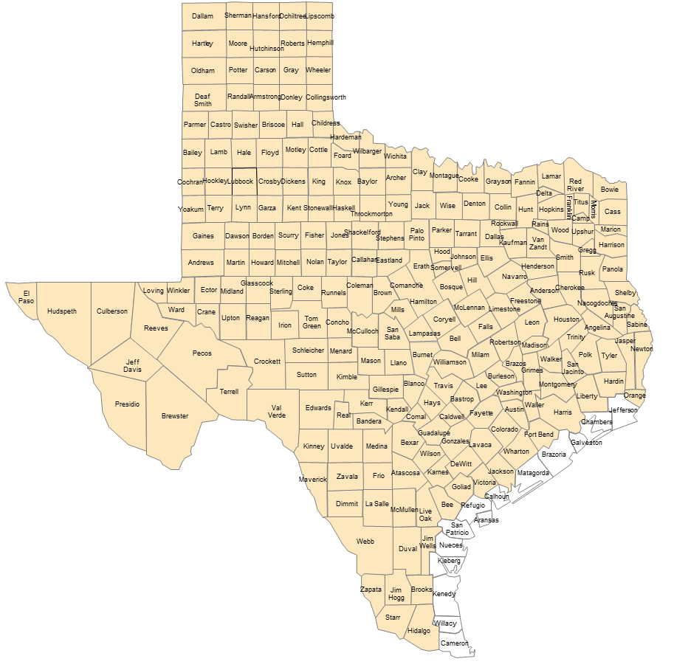
Figure 1: TFPA Coverage Area Map
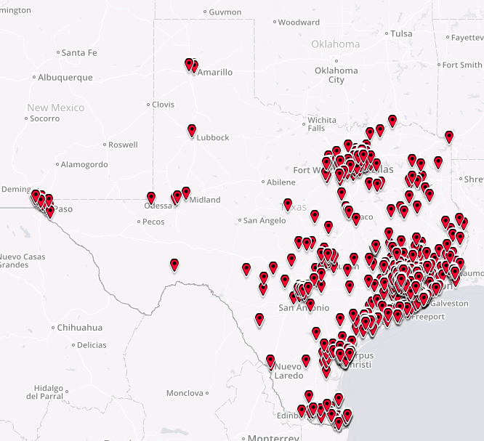
Figure 2: TFPA Policies in Force Map

TWIA
TWIA provides coverage in the 14 coastal counties and parts of Harris County listed below and illustrated in Figure 3. The map in Figure 4 identifies TWIA policy concentrations.
Aransas County – Brazoria County – Calhoun County – Cameron County – Chambers County – Galveston County – Harris County (East of Hwy 146) – Jefferson County – Kenedy County – Kleberg County – Matagorda County – Nueces County – Refugio County – San Patricio County – Willacy County
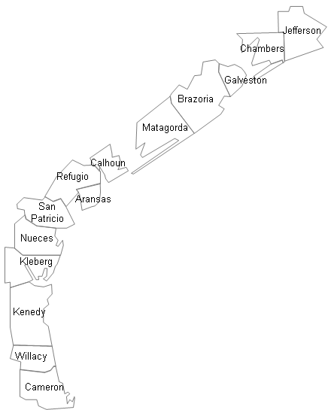
Figure 3: TWIA Coverage Area Map

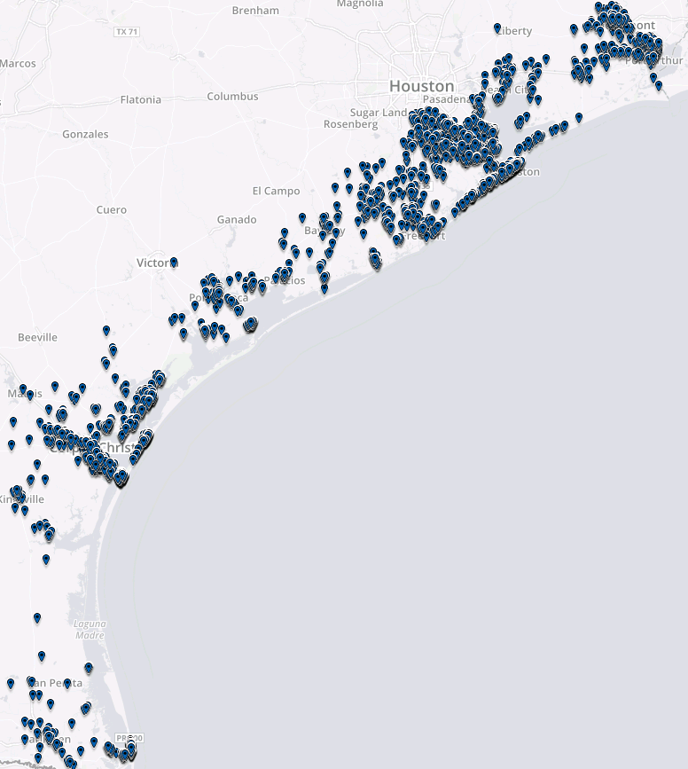
Figure 4: TWIA Policies in Force Map

Personnel Requirements
All selected Applicants represent that its employees or subcontractors selected by it for the program (“personnel”):
- Have training and are supervised by Applicant;
- Possess or are provided by the Applicant all required equipment to perform the services. (Equipment may include, but shall not be limited to: transportation, computer, estimating software, printer, ladder, digital camera, and mobile phone);
- Have access to appropriate translation services as needed; and
- Comply with all applicable legal requirements, administrative regulations, and provisions of the Texas Insurance Code and the Texas Administrative Code.
Selected Applicants must provide General Liability, Worker’s Compensation, and Errors and Omissions (“E&O”) coverage for its personnel. TWIA/TFPA will require the name of Applicant’s E&O carrier and the amount of coverage.

Right to Inspect Place of Business
At reasonable times and upon reasonable notice, TWIA/TFPA may inspect those areas of the Applicant’s place of business that are related to the performance of the contract. If TWIA/TFPA makes such an inspection, the Applicant must provide reasonable assistance with those inspections.

Business Continuity/Disaster Recovery/Information Security Plans/Ethics Policies
In accordance with recommended best practices, TWIA/TFPA vendors are required to document and maintain business continuity, disaster recovery, and information security plans, as well as an ethics policy. Applicants must provide these policies for review by TWIA/TFPA upon request. Failure to maintain satisfactory plans could be grounds for suspending business with the vendor.

Discretionary Grounds for Disqualification of Applications
TWIA/TFPA may, in its sole discretion, disqualify an application based on any of the following circumstances that apply to the Applicant or its principals:
- Any conviction of or plea of guilty to:
  - a felony;
  - a violation of any laws or regulations related to insurance or workers compensation; or
  - any other crime of moral turpitude;
- Any indictment for any items listed above;
- Actual or threatened bankruptcy proceedings;
- Any finding of fraud, breach of fiduciary duty, bad faith, unfair business practices, deceptive trade practices, or any similar finding by a court or administrative law judge;
- Any disciplinary proceedings by any governmental or regulatory entity;
- An actual or potential conflict of interest;
- Any denial, revocation, or suspension of an occupational or vocational license or certification by any public or governmental licensing agency or regulatory authority, or other disciplinary actions by such a licensing entity; or
- Any action by a licensing board or credentialing panel, including the Licensing Board of the Texas Department of Insurance.

Section 3 –Requested Services
TWIA/TFPA has a need for a wide variety of claim services, each with varying requirements and requiring different qualifications. Applicants are not required to apply for all requested adjusting-related services and selected vendors are not required to qualify for all services involved in the claims handling process (applied for or otherwise). Applicants for each service will be selected until TWIA/TFPA’s projected needs for each service have been fulfilled. This section will outline the services being requested and the specific qualifications for each service.

Field Services

Daily Residential Field Adjusting Services

Scope of Work
Daily Residential Field Adjusting Services are the field adjusting services required by TWIA/TFPA on a regular basis for residential claims not associated with a specific catastrophic event (as defined by TWIA/TFPA).
Daily Adjusting Services require a close working relationship with TWIA/TFPA over time. For the benefit of TWIA/TFPA policyholders, firms that provide both Daily and Catastrophe Adjusting Services will be the primary resources used in a catastrophe event, due to their greater familiarity with TWIA/TFPA and the development of a core of staff dedicated to TWIA/TFPA.
If awarded a contract, the selected Applicant must:
- Comply with the entirety of Section 2 – Qualifications and Requirements;
- Meet the commitments based on the Applicant’s response matrix by the deadlines set by TWIA/TFPA;
- Maintain a Texas Department of Insurance License for Adjusting Firms throughout the duration of the contract;
- Maintain a staff level that will at all times meet the adjuster experience and caseload, investigation, and reporting requirements of the contract;
- If and when requested by TWIA/TFPA, provide after-hours, weekend, and holiday service coverage;
- Follow reporting thresholds and guidelines set forth for the handling of claims by TWIA/TFPA, including the Property Damage Evaluation Guidelines; and
- Review work product for quality and compliance with guidelines set forth for the handling of claims by TWIA/TFPA.

Personnel Requirements
All selected Applicants represent that personnel selected for the program:
- Are properly licensed to adjust property claims in the state of Texas; and
- Have been certified to handle TWIA/TFPA residential claims by TWIA/TFPA through its designated certification program.

Response Instructions
This Service must be selected on question #14 in the response form. Applicants who provided this service to TWIA/TFPA at any time from 1/1/2017 to 8/1/2019 will be evaluated based on their past performance and ability to fulfill the qualifications required.
Applicants who did not provide this service to TWIA/TFPA during the above time period will need to attach document(s) which explain the firm’s plan to ensure all qualifications are met. Applicant’s submission should address each qualification for that service. Any additional material which will help TWIA/TFPA evaluate Applicant’s response and qualifications should be submitted for consideration.
TWIA/TFPA will fill this service with qualified Applicants until it reaches the resource amount that TWIA/TFPA deems necessary to fulfill its mission.

Daily Commercial Field Adjusting Services

Scope of Work
Daily Commercial Field Adjusting Services are the field adjusting services required by TWIA/TFPA on a regular basis for commercial claims not associated with a specific catastrophic event (as defined by TWIA/TFPA).
Daily Adjusting Service requires a close working relationship with TWIA/TFPA over time. For the benefit of TWIA/TFPA policyholders, firms who provide both Daily and Catastrophe Adjusting Services will be the primary resources used in a catastrophe event, due to their greater familiarity with TWIA/TFPA and the development of a core of staff dedicated to TWIA/TFPA.
If awarded a contract, the selected Applicant must:
- Comply with the entirety of Section 2 – Qualifications and Requirements;
- Meet the commitments based on the Applicant’s response matrix by the deadlines set by TWIA/TFPA;
- Maintain a Texas Department of Insurance License for Adjusting Firms throughout the duration of the contract;
- Maintain a staff level that will at all times meet the adjuster experience and caseload, investigation, and reporting requirements of the contract;
- If and when requested by TWIA/TFPA, provide after-hours, weekend, and holiday service coverage;
- Follow reporting thresholds and guidelines set forth for the handling of claims by TWIA/TFPA, including the Property Damage Evaluation Guidelines; and
- Review work product for quality and compliance with guidelines set forth for the handling of claims by TWIA/TFPA.
Personnel Requirements
All selected Applicants represent that personnel selected by it for the program:
- Are properly licensed to adjust property claims in the state of Texas; and
- Have been certified to handle TWIA commercial claims by TWIA through its designated certification program.

Response Instructions
This Service must be selected on question #14 in the response form. Applicants who provided this service to TWIA/TFPA at any time from 1/1/2017 to 8/1/2019 will be evaluated based on their past performance and ability to fulfill the qualifications required.
Applicants who did not provide this service to TWIA/TFPA during the above time period will need to attach document(s) which explain the firms plan to ensure all qualifications are met. Applicant’s submission should address each qualification for that service. Any additional material which will help TWIA/TFPA evaluate Applicant’s response and qualifications should be submitted for consideration.
TWIA/TFPA will fill this service with qualified Applicants until it reaches the resource amount that TWIA/TFPA deems necessary to fulfill its mission.

Catastrophe Residential Field Adjusting Services

Scope of Work
Catastrophe Residential Field Adjusting Services are the field adjusting services required by TWIA/TFPA in the event of a large catastrophic event for residential claims associated with that specific catastrophic event (as defined by TWIA/TFPA).
Catastrophe Adjusting Services will only occur in the event of a large catastrophic event (as defined by TWIA/TFPA) and therefore long periods of time may occur with no Catastrophe Adjusting Services. As a result, firms with a regular, sustained relationship with TWIA/TFPA through daily work will have preference for assignment during a catastrophe event for the benefit of TWIA/TFPA policyholders.
If awarded a contract, the selected Applicant must:
- Comply with the entirety of Section 2 – Qualifications and Requirements;
- Follow reporting thresholds and guidelines set forth for the handling of claims by TWIA/TFPA, including the Property Damage Evaluation Guidelines; and
- Review work product for quality and compliance with guidelines set forth for the handling of claims by TWIA/TFPA.

Personnel Requirements
All selected Applicants represent that personnel selected by it for the program:
- Are properly licensed to adjust property claims in the state of Texas; and
- Have been certified to handle TWIA/TFPA residential claims by TWIA/TFPA through its designated certification program.

Response Instructions
This Service must be selected on question #14 in the response form. Applicants who provided this service to TWIA/TFPA at any time from 1/1/2017 to 8/1/2019 will be evaluated based on their past performance and ability to fulfill the qualifications required.
Applicants who did not provide this service to TWIA/TFPA during the above time period will need to attach document(s) which explain the firms plan to ensure all qualifications are met. Applicant’s submission should address each qualification for that service. Any additional material which will help TWIA/TFPA evaluate Applicant’s response and qualifications should be submitted for consideration.
TWIA/TFPA will fill this service with qualified Applicants until it reaches the resource amount that TWIA/TFPA deems necessary to fulfill its mission.

Catastrophe Commercial Field Adjusting Services

Scope of Work
Catastrophe Commercial Field Adjusting Services are the field adjusting services required by TWIA in the event of a large catastrophic event for commercial claims associated with that specific catastrophic event (as defined by TWIA).
Catastrophe Adjusting Services will only occur in the event of a large catastrophic event (as defined by TWIA/TFPA) and therefore long periods of time may occur with no Catastrophe Adjusting Services . As a result, firms with a regular, sustained relationship with TWIA through daily work will have preference for assignment during a catastrophe event for the benefit of TWIA policyholders.
If awarded a contract, the selected Applicant must:
- Comply with the entirety of Section 2 – Qualifications and Requirements;
- Follow reporting thresholds and guidelines set forth for the handling of claims by TWIA, including the Property Damage Evaluation Guidelines; and
- Review work product for quality and compliance with guidelines set forth for the handling of claims by TWIA.

Personnel Requirements
All selected Applicants represent that personnel selected by it for the program:
- Are properly licensed to adjust property claims in the state of Texas; and
- Have been certified to handle TWIA commercial claims by TWIA through its designated certification program.

Response Instructions
This Service must be selected on question #14 in the response form. Applicants who provided this service to TWIA/TFPA at any time from 1/1/2017 to 8/1/2019 will be evaluated based on their past performance and ability to fulfill the qualifications required.
Applicants who did not provide this service to TWIA/TFPA during the above time period will need to attach document(s) which explain the firms plan to ensure all qualifications are met. Applicant’s submission should address each qualification for that service. Any additional material which will help TWIA/TFPA evaluate Applicant’s response and qualifications should be submitted for consideration.
TWIA/TFPA will fill this service with qualified Applicants until it reaches the resource amount that TWIA/TFPA deems necessary to fulfill its mission.

Inspector Services

Scope of Work
Inspector Services are not field adjusting services. Inspector Services are provided by an inspector using drone, video capture, and other imaging tools. Inspectors will not estimate, adjust, or determine coverage. As a result, inspectors are not required to be licensed claims adjusters. Inspection reports from inspector services may be used in a variety of ways, such as desk adjustment by a licensed adjuster, underwriting purposes, monitoring repairs or emergency repair progress, etc.
If awarded a contract, the selected Applicant must:
- Comply with the entirety of Section 2 – Qualifications and Requirements;
- If and when requested by TWIA/TFPA, provide after-hours, weekend, and holiday service coverage;
- Work with TWIA/TFPA to develop reporting thresholds and guidelines specific to TWIA/TFPA’s work;
- Review work product for quality and compliance with guidelines set forth for the inspection services by TWIA/TFPA;
- Have a policy and procedure for conducting background checks on individual personnel that interact with policyholders; and
- All drone use and other methods of remote imaging complies with applicable FAA and State of Texas Regulations.

Response Instructions
This Service must be selected on question #14 in the response form. TWIA/TFPA has not engaged a Vendor to provide this specific service in the past. TWIA/TFPA is looking for partners with expertise in this service who will engage with TWIA/TFPA and help TWIA/TFPA develop and implement this service into its operations.
As a result, TWIA/TFPA is interested in all possible versions of this type of service and asks that Applicants be willing to go into detail in how they have been able to provide this service to other insurance carriers and how they envision TWIA/TFPA implementing it in the future.

Contents Field Adjusting Services

Scope of Work
Contents Field Adjusting Services are the services required by TWIA/TFPA on a regular basis for the adjustment of the personal property or business personal property portion of claims, including on-site documentation, pricing, and determination of depreciation.
If awarded a contract, the selected Applicant must:
- Comply with the entirety of Section 2 – Qualifications and Requirements;
- Meet the commitments based on the Applicant’s response matrix by the deadlines set by TWIA/TFPA;
- Maintain a Texas Department of Insurance License for Adjusting Firms throughout the duration of the contract;
- Maintain a staff level that will at all times meet the adjuster experience and caseload, investigation, and reporting requirements of the contract;
- If and when requested by TWIA/TFPA, provide after-hours, weekend, and holiday service coverage;
- Follow reporting thresholds and guidelines set forth for the handling of claims by TWIA/TFPA, including the Property Damage Evaluation Guidelines; and
- Review work product for quality and compliance with guidelines set forth for the handling of claims by TWIA/TFPA.

Personnel Requirements
All selected Applicants represent that personnel selected for the program:
- Are properly licensed to adjust property claims in the state of Texas; and
- Have been certified to handle TWIA/TFPA claims by TWIA/TFPA through its designated certification program.

Response Instructions
This Service must be selected on question #14 in the response form. Applicants who provided this service to TWIA/TFPA at any time from 1/1/2017 to 8/1/2019 will be evaluated based on their past performance and ability to fulfill the qualifications required.
Applicants who did not provide this service to TWIA/TFPA during the above time period will need to attach document(s) which explain the firms plan to ensure all qualifications are met. Applicant’s submission should address each qualification for that service. Any additional material which will help TWIA/TFPA evaluate Applicant’s response and qualifications should be submitted for consideration.
TWIA/TFPA will fill this service with qualified Applicants until it reaches the resource amount that TWIA/TFPA deems necessary to fulfill its mission.

Inside Services

In-Location Desk Adjusting

Scope of Work
In-Location Desk Adjusting Services are the desk adjusting services required by TWIA/TFPA at a location designated by TWIA/TFPA and not maintained by the adjusting/staffing firm.
If awarded a contract, the selected Applicant must:
- Comply with the entirety of Section 2 – Qualifications and Requirements;
- Meet the commitments based on the Applicant’s response matrix by the deadlines set by TWIA/TFPA;
- Maintain a Texas Department of Insurance License for Adjusting Firms throughout the duration of the contract;
- Provide staff that will meet the adjuster experience and competency required; and
- Follow reporting thresholds and guidelines set forth for the handling of claims by TWIA/TFPA.

Personnel Requirements
All selected Applicants represent that personnel selected for the program:
- Are properly licensed to adjust property claims in the state of Texas;
- Have been certified to handle TWIA/TFPA claims by TWIA/TFPA through its designated certification program; and
- If and when requested by TWIA/TFPA, provide after-hours, weekend, and holiday service coverage.

Response Instructions
This Service must be selected on question #14 in the response form. Applicants who provided this service to TWIA/TFPA at any time from 1/1/2017 to 8/1/2019 will be evaluated based on their past performance and ability to fulfill the qualifications required.
Applicants who did not provide this service to TWIA/TFPA during the above time period will need to attach document(s) which explain the firms plan to ensure all qualifications are met. Applicant’s submission should address each qualification for that service. Any additional material which will help TWIA/TFPA evaluate Applicant’s response and qualifications should be submitted for consideration.
TWIA/TFPA will fill this service with qualified Applicants until it reaches the resource amount that TWIA/TFPA deems necessary to fulfill its mission.

Satellite Desk Adjusting

Scope of Work
Satellite Desk Adjusting Services are the desk adjusting services required by TWIA/TFPA at a location designated by TWIA/TFPA and maintained by the adjusting firm. TWIA/TFPA will still supervise, manage, and otherwise oversee the work at that location.
If awarded a contract, the selected Applicant must:
- Comply with the entirety of Section 2 – Qualifications and Requirements;
- Meet the commitments based on the Applicant’s response matrix by the deadlines set by TWIA/TFPA;
- Provide staff that will meet the adjuster experience and competency required;
- Follow reporting thresholds and guidelines set forth for the handling of claims by TWIA/TFPA;
- Provide work stations, technical support, and necessary equipment for subcontractors and TWIA/TFPA personnel to perform services required by TWIA/TFPA using TWIA/TFPA systems in the manner TWIA/TFPA intends and dictates; and
- Provide supervisor and support teams.

Personnel Requirements
All selected Applicants represent that personnel selected by it for the program who will adjust claims:
- Are properly licensed to adjust property claims in the state of Texas;
- Have been certified to handle TWIA/TFPA claims by TWIA/TFPA through its designated certification program; and
- If and when requested by TWIA/TFPA, provide after-hours, weekend, and holiday service coverage.

Response Instructions
This Service must be selected on question #14 in the response form. Applicants who provided this service to TWIA/TFPA at any time from 1/1/2017 to 8/1/2019 will be evaluated based on their past performance and ability to fulfill the qualifications required.
Applicants who did not provide this service to TWIA/TFPA during the above time period will need to attach document(s) which explain the firms plan to ensure all qualifications are met. Applicant’s submission should address each qualification for that service. Any additional material which will help TWIA/TFPA evaluate Applicant’s response and qualifications should be submitted for consideration.
TWIA/TFPA will fill this service with qualified Applicants until it reaches the resource amount that TWIA/TFPA deems necessary to fulfill its mission.

Customer Care

Scope of Work
Customer Care Representatives are not adjusters and not required to be licensed adjusters. In the event of a catastrophe these representatives would be used to field status calls from insureds, to answer basic questions not related to coverage, such as the status of documents or payments, and otherwise fulfill a customer service function for our policyholders.
Potentially TWIA/TFPA would like for the applicant to provide the worksite location and workstations in addition to the personnel for this group. TWIA/TFPA staff would also be deployed to this worksite to help manage and oversee the Applicant’s operations.
If awarded a contract, the selected Applicant must:
- Comply with the entirety of Section 2 – Qualifications and Requirements;
- Provide work stations, technical support, and necessary equipment for subcontractors to perform services required by TWIA/TFPA using TWIA/TFPA systems in the manner TWIA/TFPA intends and dictates;
- Provide supervisor and support teams.

Personnel Requirements
All selected Applicants represent that personnel selected by it for the program:
- If and when requested by TWIA/TFPA, provide after-hours, weekend, and holiday service coverage.

Response Instructions
This Service must be selected on question #14 in the response form. TWIA/TFPA has not engaged a Vendor to provide this specific service in the past. TWIA/TFPA is looking for partners with expertise in this service who will engage with TWIA/TFPA and help TWIA/TFPA develop and implement this service into its operations.
As a result, TWIA/TFPA is interested in all possible versions of this type of service and asks that Applicants be willing to go into detail in how they have been able to provide this service to other insurance carriers and how they envision TWIA/TFPA implementing it in the future.

Quality Assurance Services

Field Quality Assurance

Scope of Work
Field Quality Assurance Services are the quality assurance services required by TWIA/TFPA to be performed on Daily and Catastrophe Field Adjusting Service providers.
If awarded a contract, the selected Applicant must:
- Comply with the entirety of Section 2 – Qualifications and Requirements;
- Meet the commitments based on the Applicant’s response matrix by the deadlines set by TWIA/TFPA;
- Maintain a Texas Department of Insurance License for Adjusting Firms throughout the duration of the contract;
- Maintain a staff level that will always meet the quality analyst experience, caseload, and reporting requirements of the contract;
- Follow reporting thresholds and guidelines set forth for the handling of claims by TWIA/TFPA including the Outside Quality Assurance Guidelines;
- Review the work product for quality and compliance with guidelines set forth for by TWIA/TFPA; and
- Provide supervisor and support teams.
Additionally, firms cannot provide both Outside Quality Assurance and any one of the following other services for TWIA/TFPA:
- Daily Residential Field Adjusting Services;
- Daily Commercial Field Adjusting Services;
- Catastrophe Residential Field Adjusting Services;
- Catastrophe Commercial Field Adjusting Services; or
- Contents Field Adjusting Services.

Personnel Requirements
All selected Applicants represent that personnel selected by it for the program:
- Are properly licensed to adjust property claims in the state of Texas; and
- Have been certified to handle TWIA/TFPA claims by TWIA/TFPA by its designated certification program.

Response Instructions
This Service must be selected on question #14 in the response form. Applicants who provided this service to TWIA/TFPA at any time from 1/1/2017 to 8/1/2019 will be evaluated based on their past performance and ability to fulfill the qualifications required.
Applicants who did not provide this service to TWIA/TFPA during the above time period will need to attach document(s) which explain the firms plan to ensure all qualifications are met. Applicant’s submission should address each qualification for that service. Any additional material which will help TWIA/TFPA evaluate Applicant’s response and qualifications should be submitted for consideration.
TWIA/TFPA will fill this service with qualified Applicants until it reaches the resource amount that TWIA/TFPA deems necessary to fulfill its mission.

Inside Quality Assurance

Scope of Work
Inside Quality Assurance Services are the quality assurance services required by TWIA/TFPA to be performed on In-Location and Satellite Adjusting Service providers at a location designated by TWIA/TFPA.
If awarded a contract, the selected Applicant must:
- Comply with the entirety of Section 2 – Qualifications and Requirements;
- Meet the commitments based on the Applicant’s response matrix by the deadlines set by TWIA/TFPA;
- Maintain a Texas Department of Insurance License for Adjusting Firms throughout the duration of the contract;
- Provide staff that will meet the adjuster experience and competency required; and
- Follow reporting thresholds and guidelines set forth for the handling of claims by TWIA/TFPA.
Additionally, firms cannot provide both Inside Quality Assurance and any one of the following other services for TWIA/TFPA:
- In-Location Residential Desk Adjusting;
- In-Location Commercial Desk Adjusting;
- Satellite Residential Desk Adjusting; or
- Satellite Commercial Desk Adjusting.

Personnel Requirements
All selected Applicants represent that personnel selected by it for the program:
- Are properly licensed to adjust property claims in the state of Texas; and
- Have been certified to handle TWIA/TFPA claims by TWIA/TFPA by its designated certification program.

Response Instructions
This Service must be selected on question #14 in the response form. Applicants who provided this service to TWIA/TFPA at any time from 1/1/2017 to 8/1/2019 will be evaluated based on their past performance and ability to fulfill the qualifications required.
Applicants who did not provide this service to TWIA/TFPA during the above time period will need to attach document(s) which explain the firms plan to ensure all qualifications are met. Applicant’s submission should address each qualification for that service. Any additional material which will help TWIA/TFPA evaluate Applicant’s response and qualifications should be submitted for consideration.
TWIA/TFPA will fill this service with qualified Applicants until it reaches the resource amount that TWIA/TFPA deems necessary to fulfill its mission.

Section 4 - Affirmations and Certifications
By submitting a response to this RFQ, Applicant hereby certifies that:
- Favors
The Applicant has not given, offered to give, nor intends to give at any time hereafter any economic opportunity, future employment, gift, loan, gratuity, special discount, trip, favor, or service to any person with a financial interest in the operations of TWIA/TFPA in connection with the submitted RFQ application.
- Financial Interests
The Applicant has not received compensation for participation in the preparation of specifications for this solicitation.
- Antitrust
Neither the Applicant nor the firm, corporation, partnership, or institution represented by the Applicant, or anyone acting for such a firm, corporation, or institution has violated the antitrust laws of this state or federal antitrust laws.

Requirements
Applicant agrees to comply with all terms and conditions set forth in the RFQ. In submitting responses, Applicant agrees to comply with all requirements of the RFQ and any resulting contract. All parts of the RFQ may be incorporated as part of any resulting contract for all purposes.

Public Information
TWIA/TFPA is subject to the Texas Public Information Act (Tex. Gov’t Code Ch. 552). Applicant understands that TWIA/TFPA is bound by the provisions of the Texas Public Information Act and Attorney General Opinions issued under that statute. Applications submitted to TWIA/TFPA in response to this RFQ become the property of TWIA/TFPA and may be reproduced by TWIA/TFPA or subject to release by TWIA/TFPA to any requestor as public information. Any information the Applicant believes may be protected from disclosure should be clearly designated as such; such information may or may not be exempt from disclosure.

Unfair Business Practices
Applicant represents and warrants that it has not been the subject of a Deceptive Trade Practice or any unfair business practice administrative hearing or court suit and that Applicant has not been found to be liable for such practices in such proceedings. Applicant certifies that it has no officers who have served as officers of other entities who have been the subject of a Deceptive Trade Practices Act or any unfair business administrative hearing or court suit and that all officers have not been found to be liable for such practices in such proceedings.

Equal Opportunity
Applicant represents and warrants that it will comply with the Civil Rights Act in giving equal opportunity without regard to race, color, creed, sex, or national origin.

No Conflicts
TWIA/TFPA wish to avoid actual and perceived conflicts of interest and to minimize the potential for conflicts of interest. Each response shall include a statement disclosing any potential conflicts of interest (as described in Appendix B), of Applicant’s and/or any of the Applicant’s employees or personnel or affirming that no such conflicts exist. TWIA/TFPA’s determination regarding any questions about conflict of interest shall be final.

Americans with Disabilities Act (ADA)
Applicant represents and warrants that it will comply with the requirements of the Americans with Disabilities Act (ADA).

False Statements & Breach of Representations
By signature on Applicant’s RFQ response, Applicant affirms the representations, warranties, guarantees, certifications, and affirmations included in the response to this RFQ. If Applicant signs the RFQ with a false statement or it is subsequently determined that Applicant has violated any of the representations, warranties, guarantees, certifications, or affirmations included in this RFQ, Applicant will be in default under any subsequently awarded contract.
Suspension, Debarment, and Terrorism
Applicant certifies that the bidding entity and its principals are eligible to participate in this transaction and have not been subjected to suspension, debarment, or similar ineligibility determined by any federal, state, or local governmental entity and that Applicant is in compliance with any Texas licensing requirements and that Applicant is not listed on the federal government’s terrorism watch list as described in Executive Order 13224. Entities ineligible for federal procurement are listed at http://www.epls.gov.

Section 5 - Terms and Conditions
Applicants who apply to perform services for TWIA/TFPA shall agree to the terms and conditions stated below:

Governing Law
The RFQ and any resulting contract shall be governed by and construed in accordance with the laws of the State of Texas (but not rules governing conflict of law issues).

Venue
Any action or proceeding related to any resulting contract shall be brought in Travis County, Texas, and venue is proper in only such county.

Obligations for RFQ Costs
TWIA/TFPA accepts no obligations for costs incurred in responding to this RFQ in anticipation of being awarded a contract. All of the costs and expenses incurred by an Applicant in connection with or arising out of its possible or actual response to this RFQ shall be entirely the responsibility of the Applicant and shall not be borne or reimbursed directly or indirectly by TWIA/TFPA.

Obligations of Selected Applicant
Any Applicant selected by TWIA/TFPA as a vendor will be responsible for the performance of all contractual obligations that may result from an award based on this RFQ. By submitting a response, Applicant acknowledges, accepts, and agrees to all terms of this RFQ. A response to this RFQ is an offer to contract with TWIA/TFPA based upon terms, conditions, and specifications contained in this RFQ.

TWIA/TFPA Obligations
Issuance of this RFQ does not constitute a commitment on the part of TWIA/TFPA to award a contract. TWIA/TFPA is under no obligation to award any contract as a result of this RFQ. TWIA/TFPA maintains the right to reject any or all applications and to cancel this RFQ at any time. TWIA/TFPA reserves the right to select and contract with one or more Applicants to serve as vendors on an as-needed basis. No compensation of any kind is guaranteed to any Applicant.

Right to Amend, Modify, or Withdraw the RFQ
TWIA/TFPA reserves the right to alter, amend, or modify any provisions of this RFQ or to rescind, revoke, or withdraw this RFQ, in whole or in part, at any time prior to the award of any contract if it is determined by TWIA/TFPA to be in the best interest of TWIA/TFPA policyholders. TWIA/TFPA further reserves the right to issue additional RFQs or other solicitations for the contracted or similar services at any time.

Issuance of RFQs
Submitting a response to this RFQ does not generate any rights or privileges with respect to any subsequent services contract.

Rejection of Responses
TWIA/TFPA reserves the right to reject, in its sole discretion, any or all RFQ responses and all or any part of any response. TWIA/TFPA’s waiver of any deviation in any response will not constitute a modification of this RFQ. Furthermore, waiver of any deviation will not preclude TWIA/TFPA from asserting all rights against Applicant for failure to fully comply with all terms and condition of this RFQ.

Decision on Application
TWIA/TFPA’s decision to reject a response is final. Applicants will not have the opportunity to re-apply until TWIA/TFPA issues a subsequent RFQ.

Contract Period
The term of any contract resulting from this RFQ shall be from the date the contract is fully executed and shall terminate on the date included in the executed contract. TWIA/TFPA, in its sole discretion, may renew the contract as outlined in the contract. Such renewal shall be subject to all specifications and terms and conditions of the original contract. TWIA/TFPA, in its sole discretion, may elect to change fees to be paid for services by providing written notice to the selected Applicant.

Waivers and Releases
TWIA/TFPA does not waive any privileges, rights, defenses, remedies, or immunities available to it or any other rights available to TWIA/TFPA. By submitting an application, Applicant releases TWIA/TFPA, its General Manager, its Board of Directors, and its employees and agents from any and all liability, claims, and lawsuits with respect to the information submitted by Applicant or obtained by TWIA/TFPA in connection with this RFQ.

Auditing Contractor’s Performance
TWIA/TFPA may, at its option, perform periodic audits of the Applicants selected through this RFQ. The audit may include, but not be limited to, a review of one or more of the following areas:
- Compliance with procedures, controls, adjuster experience, and caseload limits established by TWIA/TFPA, or applicable state regulatory agencies;
- The quality of expertise with which claims have been handled;
- The degree of promptness and efficiency in claims handling;
- The adequacy and accuracy of payments and establishment/maintenance of reserves;
- The adequacy and quality of file documentation and analysis of compensability issues;
- The proper use of electronic reporting and electronic file documentation; and
- The adequacy of communication with TWIA/TFPA, policyholders, agents, Texas Department of Insurance, state agencies, and all of our other stakeholders involved in claims.
These audits may be conducted, at the option of TWIA/TFPA, at the Applicant’s location or at the offices of TWIA/TFPA. These audits will be in addition to daily monitoring of claims by TWIA/TFPA.

Media Releases or Pronouncements
Applicant understands that TWIA/TFPA does not endorse any vendor, commodity, or service. Neither Applicant, Applicant’s personnel, nor its principals or representatives may issue any media release, advertisement, publication, or other pronouncement which pertains to the contract or the services to which the contract relates, or which mentions TWIA/TFPA without prior written approval of TWIA/TFPA.
Applicant shall not use any trade name, service mark, or any other information which identifies TWIA/TFPA in sales (including prospective client meetings), marketing, and publicity activities, including, but not limited to, interviews with representatives of any written publication, television station or network, or radio station or network without TWIA/TFPA’s prior written authorization.

Ownership of Documents
All application data Applicant prepares and submits under this RFQ, and any other related documents or items, to include electronic and non-electronic data, shall become the sole property and ownership of TWIA/TFPA.

Independent Contractor
It is expressly understood and agreed that selected Applicant is and shall be deemed to be an independent contractor, responsible for Applicant’s respective acts or omissions, and that TWIA/TFPA shall in no way be responsible therefore, and that neither party hereto has authority to bind the other or to hold out to third parties that it has the authority to bind the other. Nothing contained herein shall be deemed or construed by the parties hereto, or by any third party, as creating the relationship of employer-employee, principal-agent, partners, joint venture, or any other similar such relationship between the parties hereto.

Additional Terms and Conditions
Any terms and conditions attached or submitted with a response to the RFQ will not be considered by TWIA/TFPA unless the Applicant specifically refers to them and requests approval of such terms and conditions.

Section 6 – Instructions for Response and Definitions

Instructions for Response
Responses should be completed through the weblink provided
https://www.research.net/r/5JQT6CC
The Response Form will guide Applicants through the process. All questions presented to the Applicant must be completed. Once the Applicant has selected one or more services in question #14, a series of additional questions specific to the service(s) will be provided and must be completed. Applicants are encouraged to use the file upload links provided within the response form. Should technical difficulties occur where an attachment cannot be uploaded, the Applicant may also submit the attachment in question via email to ClaimsVendorServices@twia.org with the associated response question number indicated in the file name.

Questions
All questions should exclusively be submitted to the ClaimsVendorServices@twia.org by August 30th, 5pm Central Time. Any question received after that time or communicated in any manner other than the ClaimsVendorServices@twia.org email will not be addressed by TWIA/TFPA.
TWIA/TFPA reserves the right to ask applicants questions or for clarifications to their RFQ responses at any time after the submission deadline of October 18th before making awards.

Timeline of Events
August 16th - Release date for RFQ

August 30th 5pm Central Time - Deadline for submission of questions concerning RFQ

September 13th – TWIA/TFPA Responses to questions posted in same area of its website

October 18th 5pm Central Time – Deadline for submissions to RFQ

November – December – TWIA questions and clarification requests for applicants
December 20th, 2019 - Awards

January 6th , 2020– Anticipated contract finalization and service start date

Definitions
All terms used in this RFQ are TWIA/TFPA-specific unless otherwise noted.

Catastrophe Claims or “Catastrophic” Claims are claims associated with a catastrophic event, as designated by TWIA/TFPA.

Daily Claims or “Non-Catastrophic” Claims are those not deemed to be associated with a catastrophic event, as designated by TWIA/TFPA.

In-Location is a location at TWIA/TFPA’s designation, directly maintained and supported by TWIA/TFPA

Satellite is a location at the applicant’s designation, managed and overseen by TWIA/TFPA but maintained and supported by the applicant.

Frequently Asked Questions
What is the typical claim volume for TWIA and TFPA?
In 2018 TWIA received 7,242 claims, TFPA received 5,720 claims. For Hurricane Harvey alone in 2017 TWIA received 73,930 claims and TFPA received 16,920 claims. TWIA and TFPA’s claim volume is highly volatile year-to-year.
How will that volume be spread through the IA firms?
For Daily work TWIA has a vendor management program in place consisting of monitoring cycle time, on-site physical reinspection of claims, customer surveys, and other quality control measures. Firms are ranked against their peers to monitor performance. If firms are meeting expectations and actively receiving work those firms receive work on an automatic rotation basis with exception for special situations and/or assignments.
What are the policy counts and exposures for TWIA?
195,530 policies as of 7/31/2019
What are the policy counts and exposures for TFPA?
91,404 policies as of 7/31/2019
To ensure compliance with the consanguinity and affinity requirement of the contract is there a website listing employees and board members to ensure compliance with this requirement?
TWIA/TFPA requires the respondent to disclose any actual or perceived conflict that they are aware of, both before award of a contract as well as whenever they first become aware of the potential conflict of interest. If the respondent has a specific question on whether a relationship constitutes an actual or perceived conflict of interest, they can directly inquire about it with our Legal & Compliance department by addressing an email to ClaimsVendorServices@twia.org to them.
I’ve made a mistake; can I go back and edit my submission?

Applicants can edit their submission at any time up to the submission deadline of October 18th, 5pm CST. The response form recognizes the computer the Applicant is using in order to match them up with their response. This means that if the Applicant clears their internet browser cookies, cache, or uses a different computer, they will not be able to edit their response after it has been submitted.

Appendix A – Example Response

Appendix B
* Please review this information carefully as you must acknowledge this Appendix B as part of your RFQ submission in the signature section of the web form. An actual signed copy of this form is not needed until Awards/Contracts.
All TWIA/TFPA vendors and contractors shall conduct their affairs in an ethical manner so as to try to avoid actual or perceived conflict between such personal interests and the interests of TWIA/TFPA. Conflicts of interest may be considered to exist in those instances where the actions or activities of an individual on behalf of TWIA/TFPA also may result in improper personal gain or advantage to the individual or a family member, adverse effect upon TWIA/TFPA's interests, and/or improper gain or advantage to a third party.
Pursuant to Texas Insurance Code Section 2210.013, TWIA/TFPA shall not contract with a third party for the provision of goods or services in connection with the operation or business of the association, if the third party is to be directly or indirectly compensated from funds of the association, and is related to a member of the board of directors or employee of the association within a degree of relationship described by Section 573.002, Government Code.
In other words, third parties employing or contracting with a relative of a TWIA/TFPA employee or board member are not eligible to contract with TWIA/TFPA.
Section 573.002, Government Code means relationships within the third degree by consanguinity or within the second degree by affinity.
Two individuals are related to each other by consanguinity if:
- one is a descendant of the other; or
- they share a common ancestor.
An adopted child is considered to be a child of the adoptive parent for this purpose. Two individuals are related to each other by affinity if:
- they are married to each other; or
- the spouse of one of the individuals is related by consanguinity to the other individual.
The ending of a marriage by divorce or the death of a spouse ends relationships by affinity created by that marriage unless a child of that marriage is living, in which case the marriage is considered to continue as long as a child of that marriage lives.

Consanguinity and Affinity Relationship Chart
Officer or Employee
Consanguinity  (Includes individuals related by blood to the Officer or Employee) |  |  | Affinity  (Includes the Officer’s or Employee’s Spouse and individuals related to the Spouse)
First Degree | Second Degree | Third Degree | First Degree | Second Degree | Third Degree
Father or Mother | Grandparents | Great Grandparents | Spouse | Grandparents | Great Grandparents
Son or Daughter (& Spouse) | Grandchildren (& Spouse) | Great Grandchildren (& Spouse) | Father or Mother | Grandchildren | Great Grandchildren
 | Uncle or Aunt (& Spouse) | Great Uncle or Aunt  (& Spouse) | Son or Daughter | Uncle or Aunt | Great Uncle or Aunt
 | First Cousin (& Spouse) | Children of Great Uncle or Aunt  (& Spouse) |  | First Cousin | Children of Great Uncle or Aunt
 | Nephew or Niece  (& Spouse) | Second Cousin (& Spouse) |  | Nephew or Niece | Second Cousin
 | Brother or Sister  (& Spouse) | Children of First Cousin (& Spouse) |  | Brother or Sister | Children of First Cousin
 |  | Grand Nephew or Niece  (& Spouse) |  |  | Grand Nephew or Niece
An Officer or Employee is the starting point from which all degrees of relationship are calculated.
Under the Degrees of Consanguinity, where Spouse is indicated, the relationship of the spouse is in the same degree as that of the person related by consanguinity, but the spouse is related only by affinity.
Although the same statutory language does not exist for TFPA under Chapter 2211, these standards will be applied in any TFPA operations or procedures.
A vendor or contractor who violates these standards is subject to termination of any contract with TWIA or TFPA. In addition, a person who violates these requirements may be subject to any applicable civil or criminal penalty if the violation also constitutes a violation of any statute or rule.

Ethics and Conflicts of Interest Disclosure and Acknowledgement
Please disclose the following:
- any previous, current, or planned business or personal relationship between you and an employee or board member of TWIA/TFPA; and/or
- any business relationship or proposed transaction you have or had with the Associations in which you or a family member have or had a direct or indirect interest, and/or derived or may derive a benefit.
Entity or Individual Name Nature of Relationship (Business, Personal)
_______________________________ ____________________________________________________
_______________________________ ____________________________________________________
_______________________________ ____________________________________________________
_______________________________ ____________________________________________________
If you have additional information to disclose, please attach a separate sheet of paper to this document with that information.
By my signature below, I state that I have reviewed this Attachment C, Ethics and Conflicts of Interest. My signature below confirms my acknowledgement of the standards contained herein, including the prohibition against contracting with TWIA/TFPA if I am, or any employee or contractor of my company is, related to a TWIA/TFPA employee or board member to the third degree by consanguinity or within the second degree by affinity. It also constitutes my certification that I am not aware of any conflict or potential conflict covered by this Attachment C that is not disclosed herein.

Authorized Signature Printed Name & Title

Date Entity

